1. Kiến trúc project base chuẩn
.
├── Dockerfile
├── README.md
├── docker-compose.yml
├── initdb.sql
├── pom.xml
└── src
├── main
│ ├── java
│ │ └── vn
│ │ └── tayjava
│ │ ├── BackendServiceApplication.java
│ │ ├── common
│ │ ├── config
│ │ │ └── OpenApiConfig.java
│ │ ├── controller
│ │ ├── exception
│ │ ├── model
│ │ ├── repository
│ │ └── service
│ └── resources
│ ├── application-dev.yaml
│ ├── application-prod.yaml
│ ├── application-test.yaml
│ ├── application.yaml
│ ├── banner.txt
│ ├── static
│ └── templates
└── test
└── java
└── vn
└── tayjava
└── BackendServiceApplicationTests.javaCopy

2. Lựa chọn công nghệ
- Java 17 hoặc 21 hoặc 25
- Spring Boot 3 (mới nhất)
- Postgres / Mysql
- Maven 3.5 ++
- Docker
- Tools: IntelliJ, DBeaver

3. Các bước tạo project
– Bước 1: Tạo project
Tạo mới project trên https://start.spring.io
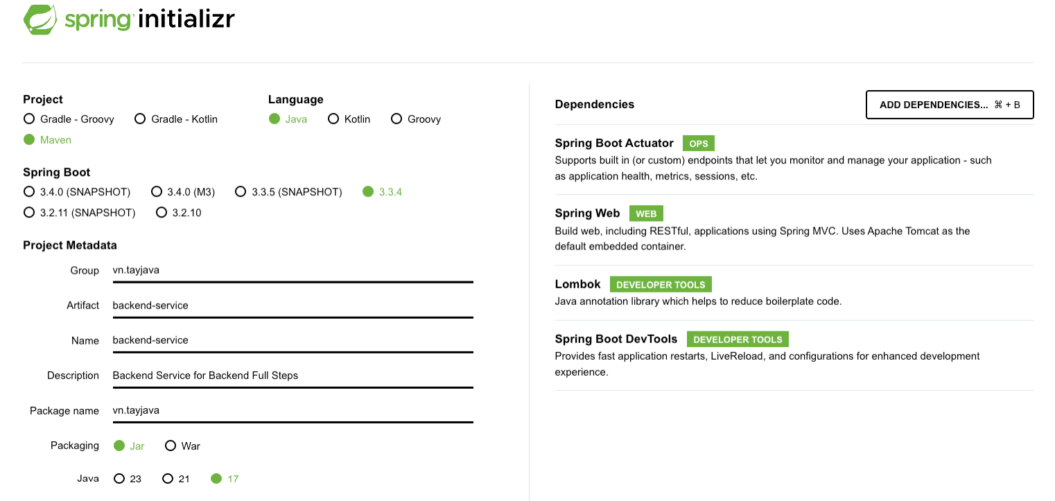
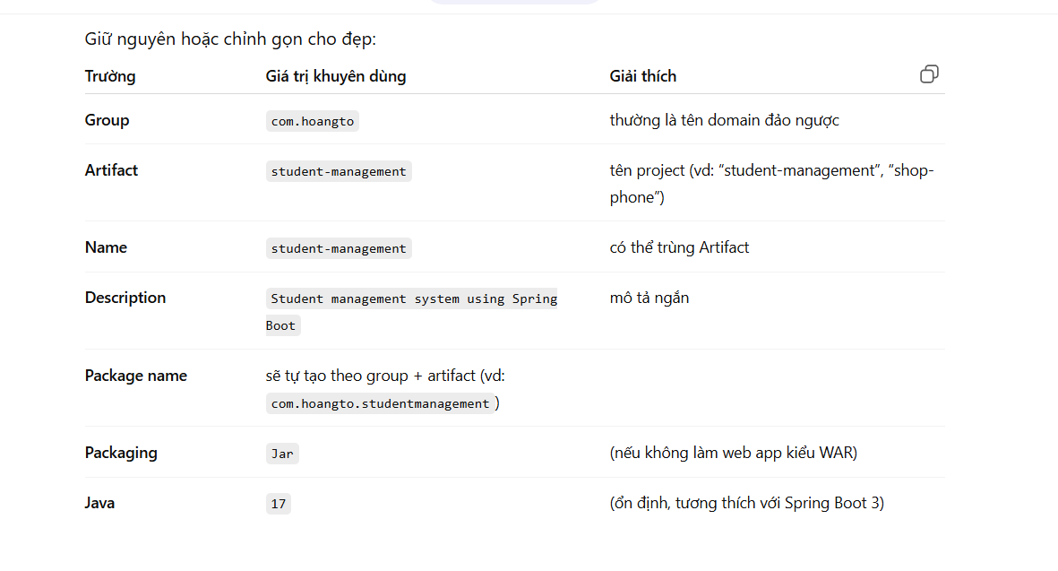

– Bước 2: Tạo banner cho backend-service
– Tạo banner và download banner.txt tại Spring Boot banner Generator | Create banner.txt online
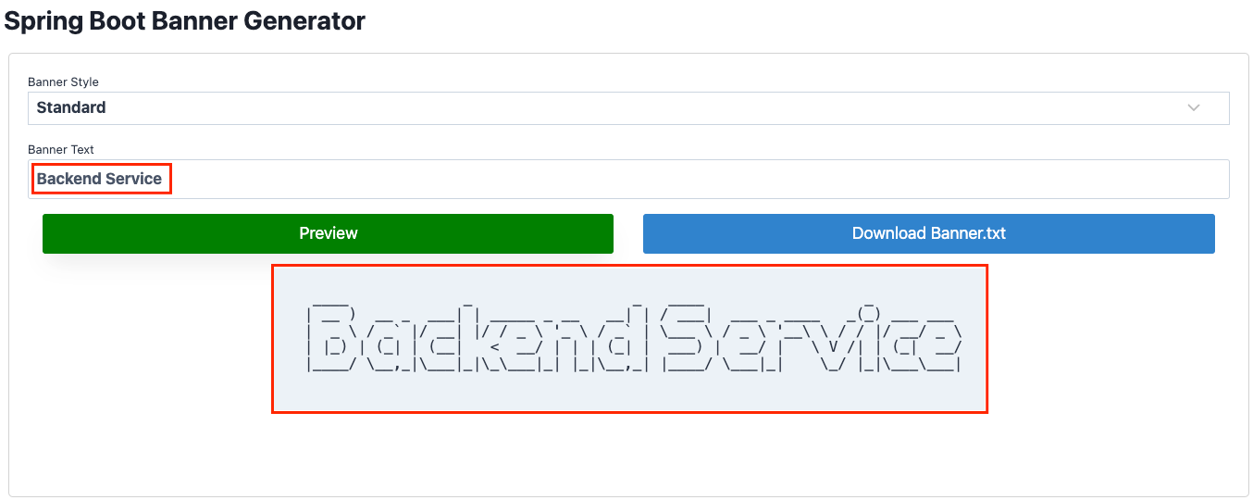
– Thêm banner.txt vào folder resources
│ └── resources
│ ├── banner.txt
│ ├── ...Copy

– Bước 3: Thiết lập maven profile để build application
– pom.xml
<profiles>
<profile>
<id>dev</id>
<activation>
<activeByDefault>true</activeByDefault>
</activation>
<properties>
<spring.profiles.active>dev</spring.profiles.active>
</properties>
</profile>
<profile>
<id>test</id>
<properties>
<spring.profiles.active>test</spring.profiles.active>
</properties>
</profile>
<profile>
<id>prod</id>
<properties>
<spring.profiles.active>prod</spring.profiles.active>
</properties>
</profile>
</profiles>
– application.yaml
server:
port: 8080

spring:
application:
name: backend-service
profiles:
active: @spring.profiles.active@

management:
endpoints:
web:
exposure:
include: '*'

logging:
level:
root: INFO
web: INFOCopy
– application-dev.yaml
spring:
config:
activate:
on-profile: dev
devtools:
add-properties: true
datasource:
url: jdbc:postgresql://${DATABASE_URL:localhost:5432/postgres}
username: ${DATABASE_USERNAME:dev}
password: ${DATABASE_PASSWORD:password}
hikari: # Connection poll
max-lifetime: 300000 # 5 phút
idle-timeout: 60000 # 1 phút
validation-timeout: 5000 # 5 giây
minimum-idle: 5
maximum-pool-size: 20
jpa:
show-sql: false
hibernate:
ddl-auto: noneCopy
– application-test.yaml
spring:
config:
activate:
on-profile: dev
devtools:
add-properties: true
datasource:
url: jdbc:postgresql://${DATABASE_URL:localhost:5432/postgres}
username: ${DATABASE_USERNAME:dev}
password: ${DATABASE_PASSWORD:password}
hikari: # Connection poll
max-lifetime: 300000 # 5 phút
idle-timeout: 60000 # 1 phút
validation-timeout: 5000 # 5 giây
minimum-idle: 5
maximum-pool-size: 20
jpa:
show-sql: false
hibernate:
ddl-auto: noneCopy
– application-prod.yaml
spring:
config:
activate:
on-profile: prod
devtools:
add-properties: true
datasource:
url: jdbc:postgresql://${DATABASE_URL:localhost:5432/postgres}
username: ${DATABASE_USERNAME:dev}
password: ${DATABASE_PASSWORD:password}
hikari: # Connection poll
max-lifetime: 300000 # 5 phút
idle-timeout: 60000 # 1 phút
validation-timeout: 5000 # 5 giây
minimum-idle: 5
maximum-pool-size: 20
jpa:
show-sql: false
hibernate:
ddl-auto: noneCopy

– Dockerfile
FROM openjdk:17
ARG JAR_FILE=target/*.jar
COPY ${JAR_FILE} backend-service.jar
ENTRYPOINT ["java", "-jar", "backend-service.jar"]
EXPOSE 8080Copy
– docker-compose.yaml
services:

postgres:
image: postgres
container_name: postgres
restart: unless-stopped
environment:
POSTGRES_USER: postgres
POSTGRES_PASSWORD: password
PGDATA: /data/postgres
volumes:
- postgres:/data/postgres
- ./initdb.sql:/docker-entrypoint-initdb.d/init.sql
ports:
- '5432:5432'
networks:
- default

backend-service:
container_name: backend-service
build:
context: ./
dockerfile: Dockerfile
ports:
- "8080:8080"
env_file:
- .env
environment:
DATABASE_HOST: host.docker.internal
DATABASE_PORT: 5432
DATABASE_USERNAME: postgres
DATABASE_PASSWORD: password
networks:
- default

networks:
default:
name: backend-network

volumes:
postgres:Copy

– .env Được sử dụng tại file docker-compose.yaml. Các bạn có thể thay đổi giá trị trong file nhé!
DATABASE_URL=localhost:5432/postgres
DATABASE_USERNAME=dev
DATABASE_PASSWORD=passwordCopy

– Bước 4. Thiết lập API document để test API
– Thêm dependency vào pom.xml
<dependency>
<groupId>org.springdoc</groupId>
<artifactId>springdoc-openapi-starter-webmvc-ui</artifactId>
<version>2.2.0</version>
</dependency>Copy
– Tạo class OpenApiConfig tại package vn.tayjava.config Cấu hình OpenAPI
import io.swagger.v3.oas.models.Components;
import io.swagger.v3.oas.models.OpenAPI;
import io.swagger.v3.oas.models.info.Info;
import io.swagger.v3.oas.models.info.License;
import io.swagger.v3.oas.models.security.SecurityRequirement;
import io.swagger.v3.oas.models.security.SecurityScheme;
import io.swagger.v3.oas.models.servers.Server;
import org.springdoc.core.models.GroupedOpenApi;
import org.springframework.beans.factory.annotation.Value;
import org.springframework.context.annotation.Bean;
import org.springframework.context.annotation.Configuration;
import org.springframework.context.annotation.Profile;

import java.util.List;

@Configuration
@Profile({"dev", "test"})
public class OpenApiConfig {

@Bean
public GroupedOpenApi publicApi(@Value("${openapi.service.api-docs}") String apiDocs) {
return GroupedOpenApi.builder()
.group(apiDocs) // /v3/api-docs/backend-service
.packagesToScan("vn.tayjava.controller")
.build();
}

@Bean
public OpenAPI openAPI(
@Value("${openapi.service.title}") String title,
@Value("${openapi.service.version}") String version,
@Value("${openapi.service.server}") String serverUrl) {
final String securitySchemeName = "bearerAuth";
return new OpenAPI()
.servers(List.of(new Server().url(serverUrl)))
.components(
new Components()
.addSecuritySchemes(
securitySchemeName,
new SecurityScheme()
.type(SecurityScheme.Type.HTTP)
.scheme("bearer")
.bearerFormat("JWT")))
.security(List.of(new SecurityRequirement().addList(securitySchemeName)))
.info(new Info().title(title)
.description("API documents for Backend service")
.version(version)
.license(new License().name("Apache 2.0").url("https://springdoc.org")));
}

}Copy
– Thiết lập cấu hình OpenAPI tại các file *.yaml
# application-dev.yml
springdoc:
api-docs:
enabled: true
swagger-ui:
enabled: true
openapi:
service:
api-docs: backend-service
server: http://localhost:${server.port}
title: Backend service
version: 1.0.0Copy
# application-test.yml
springdoc:
api-docs:
enabled: true
swagger-ui:
enabled: true
openapi:
service:
api-docs: backend-service
server: ${BACKEND_SERVICE:http://localhost:${server.port}}
title: Backend service
version: 1.0.0Copy
# application-prod.yml
springdoc:
api-docs:
enabled: false
swagger-ui:
enabled: falseCopy

4. Viết hướng dẫn thiết lập môi trường làm việc tại README.md
– Cần viết hướng dẫn chi tiết để bất kỳ ai khi tham gia vào dự án đều có thể cài đặt và thiết lập môi trường dev một cách dễ dàng.
Dưới dây là mẫu README.md cho các dự án:
____ _ _ ____ _
| __ ) __ _ ___| | _____ _ __ __| | / ___| ___ _ ____ _(_) ___ ___
| _ \ / _` |/ __| |/ / _ \ '_ \ / _` | \___ \ / _ \ '__\ \ / / |/ __/ _ \
| |_) | (_| | (__| < __/ | | | (_| | ___) | __/ | \ V /| | (_| __/
|____/ \__,_|\___|_|\_\___|_| |_|\__,_| |____/ \___|_| \_/ |_|\___\___|

## 1. Prerequisite
- Cài đặt JDK 17+ nếu chưa thì cài đặt JDK
- Install Maven 3.5+ nếu chưa thì cài đặt Maven
- Install IntelliJ nếu chưa thì cài đặt IntelliJ
- Install Docker nếu chưa thì cài đặt Docker

## 2. Technical Stacks
- Java 17
- Maven 3.5+
- Spring Boot 3.x.x
- Spring Data Validation
- Spring Data JPA
- Postgres/MySQL (optional)
- Lombok
- DevTools
- Docker
- Docker compose

## 3. Build & Run Application
– Run application bởi mvnw tại folder backend-service
```
$ ./mvnw spring-boot:run
```

– Run application bởi docker
```
$ mvn clean install -P dev
$ docker build -t backend-service:latest .
$ docker run -it -p 8080:8080 --name backend-service backend-service:latest
```

## 4. Test
– Check health với cURL
```
curl --location 'http://localhost:8080/actuator/health'
```
-- Response --
```
{
"status": "UP"
}
```Copy

5. Testing
– Truy cập Backend service để test các API
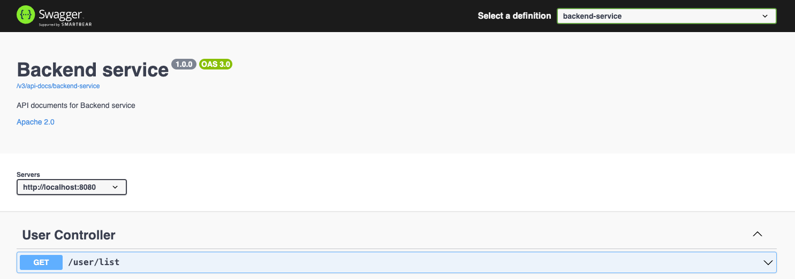
0 lượt xem

